
National Textile University
Department of Computer Science
Subject
MAD
Submitted to:
Dr. Rehan Server

Submitted by:
Hadi Muhammad
Registration Number
23-NTU-CS-1160

Lab no
05
Semester
6th
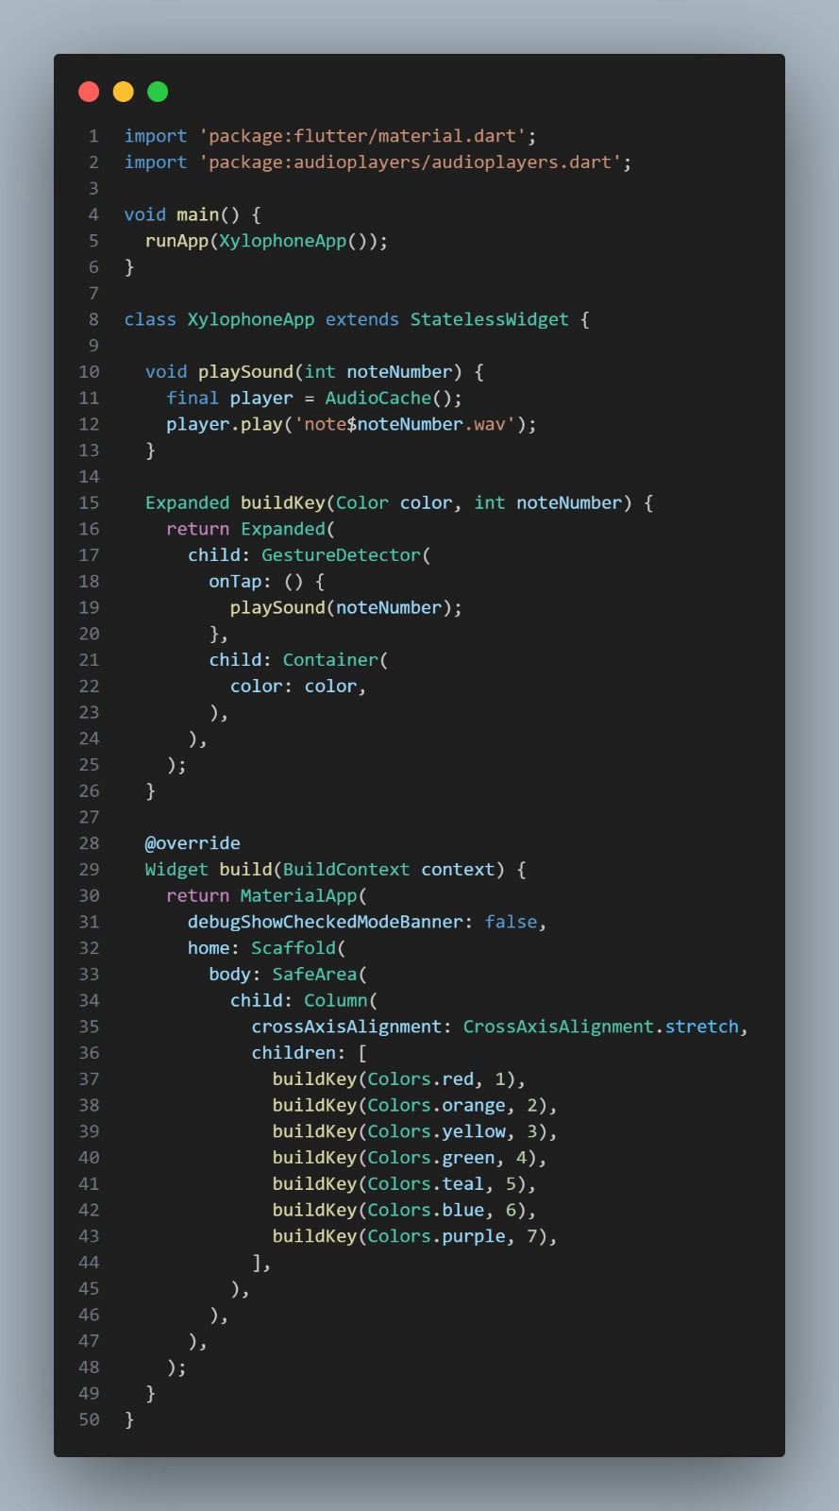
Output


